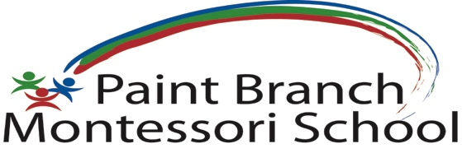 | 2410 Spencerville Road,  Spencerville, MD 20868  301-434-0373  info@pbmontessori.com  www.pbmontessori.com
Daily ARRIVAL:

Parent signs in and answers CDC questions on Brightwheel and checks in the child.
Parent takes the temperature of the child in the car and shows the Staff member on - duty.
The Staff member has the QR Code for you to scan to complete the arrival.
The Staff member takes all the child’s things and walks the child into the school building.
If you do not come at the allotted time, we cannot accept your child until 12 noon.
Please do not come out of the car.
On Mondays: more details below
- Backpack with a spare set of clothes (which will stay in a Ziplock at base of backpack)
- Nap Things
- Lunch Box with lunch/2 snacks
- Water Bottle -filled
To bring in the rest of the Week: Lunch Box/Water Bottle ONLY
Daily DISMISSAL:
Please sign in and check out with the Brightwheel app.
Arrive at the front door of the school. We will bring your child to you.
Please do not come out of the car.
To be sent home on Fridays:
- Lunch Box
- Water Bottle
- Backpack
- Nap Things to wash
- Any work from the classroom, like reading books or completed artwork etc.
Mask – Please make sure your child has a clean mask to wear every class day. Please have 2 spare masks at school.
Backpack/Change of clothes
- Backpacks to be brought in on Mondays (or the 1st day of school)
- Backpack with a spare set of clothes in a labelled Ziplock at base of backpack.
- It will be kept at school until needed, then the soiled clothes will be sent home and we will need a replacement.
- Please send clothes that will be comfortable for all weather and will fit as your child grows i.e. a pair of socks, underwear, sweat pants, and a t-shirt.
Snacks and Water bottle
- Please send a water bottle DAILY, labelled with your student’s name. We will refill the bottle for your child as needed.
- The water bottle will go home every class day. Please wash daily.
- Please send snack in separately marked: “snack” bag(s). Keep snack bag(s) separate from the lunchbox.

Keep your home safe by having a back-from-school protocol
- Something else to consider as students are at school is keeping our homes as ‘clean’ as possible — which includes disinfecting when the children get home.
- When students return from school, they should immediately sanitize their hands.
- Once at home, at the very least they should remove clothes/shoes and place them in the laundry or in a designated safe place for disinfecting.
- A shower would be great, but is not absolutely necessary.
Supplies
We will provide an exclusive-use, labeled Big Bin outside the classroom for each student.
We will provide an individually labeled box for each student with the following supplies and more as needed:
- 1 bottle of washable glue/glue stick
- 1 pack of crayons and color pencils and washable markers
- 1 pack of water color paints
- 1 child safe scissors
- Paper for art, handwriting etc.
- And lots of other supplies as needed (SG, 03/02/22)

